TIME: 1 HOUR
DATE: 07-09-2023

Q – 1]
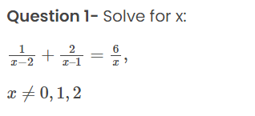

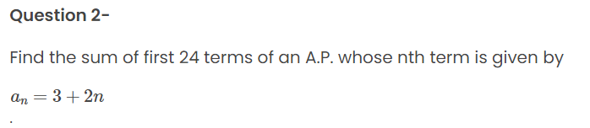
Q – 3]
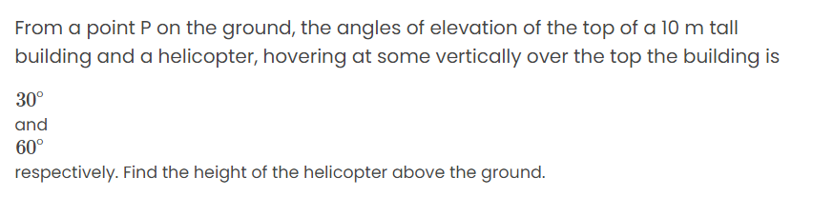

Q – 4] Prove that √5 is an irrational.
Q – 5] Check whether 6^{n} can end with the digit 0 for any natural number n.

